**Assignment No. :**

**Title:** DHCP

**Aim:** Installing and configure DHCP server and write a program in python to install the software on remote machine

**Objective:**

1. To study and understand DHCP installation steps and DHCP Server configuration.
2. To understand installation of software on remote machine.

**Theory:**

**Dynamic Host Configuration Protocol** (**DHCP**)

DHCP is a client/server protocol used to enable clients‬to obtain configuration information‬for operation in an IP network.‬DHCP is used to shrinks system administration workload by permitting DHCP clients to be added to an IP network with little or no manual intervention‬through the allocation of network addresses and additional configuration option.

DHCP is defined by two components:‬a protocol for delivering host-specific configuration parameters from a DHCP server to a host and a mechanism for allocation of network‬addresses to hosts.DHCP was created by the Dynamic Host Configuration Working Group at the Internet Engineering Task Force. It was originally defined in RFC 1531 in October 1993 as a superset of the BOOTstrap Protocol (BOOTP).

**The Need for DHCP**

When first creating TCP/IP, the designers decided to provide a separate mechanism for each item of configuration information. As such, the Reverse Address Resolution Protocol (RARP) was created (RFC 903) to only allow computers to find out its own IP address. When subnet masks were introduced, ICMP Address Mask messages were created to allow a computer to obtain a subnet mask. This allows a great deal of flexibility but at the cost of network traffic and delay. As more configuration information become available, TCP/IP designers observed that many of the configuration steps could be combined into one single step. To circumvent this problems, the designers created the BOOTstrap Protocol (BOOTP) in RFC 951. BOOTP was designed for manual pre-configuration of the host information in a server database. This helped to simplify configuration information and reduced the overall number of servers required on a network. When a BOOTP server receives a request, the computer is looked up in its database of information. If the computer is not found, it does not receive any configuration information. Thus, a computer cannot connect to a new network until the administrator manually adds information to the database.

BOOTP works well in relatively static environments. However, as computers got smaller and lighter, it was common for them to move from one network to another, requiring a new IP address while the previous one was still assigned to it until manual intervention. Keeping track of all these IP address changes became be a daunting task. This coupled with the limited number of IP addresses in an organization lead to a new protocol.

To automate configuration, the IETF created DHCP to allow for the dynamic allocation of network addresses and configurations to newly attached hosts with no manual intervention. DHCP was originally designed as a successor to BOOTP. As such, it maintains some backward compatibility and many DHCP servers support BOOTP clients. DHCPv6 drops this compatibility to produce a cleaner implementation.DHCPv4 utilizes UDP port 67 for the server side and UDP port 68 on the client side.

When a DHCP client connects to a network, it sends a broadcast query message to find the DHCP servers on the network.

1. All DHCP servers on the network that receive the message and contain a valid address configuration for the client send an IP address offer back to the DHCP client.
2. From the offers received, the client chooses an IP address configuration to use. The server that sent the offer the client selected, receives a broadcasted request message to use the selected configuration. The other DHCP servers that sent offers receive this broadcasted message, realize the request for another server, and reclaim the offered IP address.
3. The DHCP server selected by the client, assigns the IP address configuration to the DHCP client and sends an acknowledgement message to the client to verify the acceptance.

After the client obtained an IP address; the client may start an address resolution (ARP) query to prevent IP conflicts caused by address pool overlapping of DHCP servers.

#### Lease Renewal

Before the lease time expires, the client will request to extend the lease by sending a request to the server. The server will update and extend the lease time and send an acknowledgment message to the client, letting it know the lease has been extended. If the client does not receive an‬acknowledgement message, it assumes the server is down and tries to renew the lease again after the lease period is 87.5% done. If it does not receive and ‬acknowledgement this time, it will retry renewing one last time. If the client does not receive a response this final time, the lease expires and it releases the IP and starts at step 1 above.

**Address Allocation Policies**

Generally, depending on the implementation, there are three methods for a DHCP Server to allocate IP-addresses. It is also possible to combine these methods, in a hybrid allocation policy.

**Manual (or Static) Allocation**

The DHCP Server's administrator manually assigns a permanent IP address to a client, usually using a MAC address for the client identifier. The subsequent client identifier/IP address pair is stored in a table. Only requesting clients in this table will be given configuration information. This method of allocation is functionally equivalent to BOOTP though the protocol is incompatible.

**Dynamic Allocation**

The DHCP Server's administrator specifies a pool of IP addresses to be automatically assigned to clients for a specified limited period of time. IP address that are not renewed before the period of time ends or have their lease canceled are reclaimed and can be reallocated.

**Automatic Allocation**

The DHCP Server's administrator specifies a pool of IP addresses to be permanently assigned to clients. Upon request, a free IP address in this range is automatically assigned to a client. Once associated with a client, the IP address is permanently assigned to the client until the server's administrator intervenes. Many DHCP Servers do not implement this method of allocation, as it can be approximated with long lease times in dynamic allocation.

### DHCP State Diagram

DHCP is a state-full protocol .Refer to the following diagram in the following explanations

. [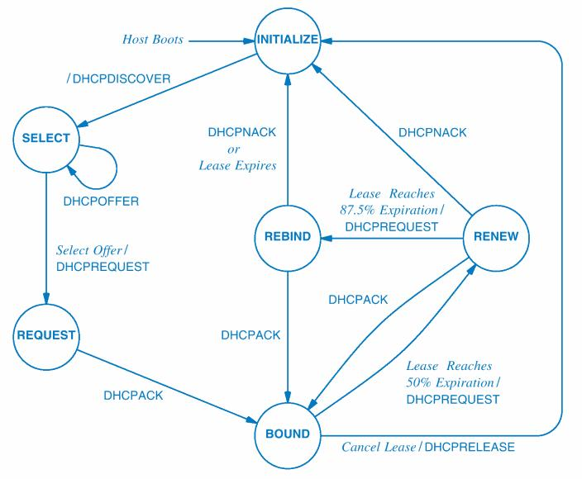](http://wiki.cas.mcmaster.ca/index.php/File:DHCP_state_Diagram.jpg)

### DHCP Initialization

DHCP operations fall into four basic phases. These phases are IP discovery(DHCPDISCOVER‬), IP lease offer(DHCPOFFER‬), IP request (DHCPREQUEST‬), and IP lease acknowledgment (DHCPACK‬).

### DHCP Discovery

Upon connection to a network, the DHCP client (in the INITIALIZE state) will send out a broadcast message on the physical subnet to find DHCP servers. This message is in the form of a UDP DHCPDiscover packet and usually at least contains the clients MAC address in the OPTIONS section, with the broadcasted destination of 255.255.255.255 (or 0.0.0.0, depending on the implementation) or subnet broadcast address.

If the client previously had an IP address, it can request this IP address again by placing the previous IP address in the OPTIONS section of the DHCPDiscover message. Provided the the IP address is still valid in the network, the server might grant the request. If the address is not valid,the actions taken depend on whether or not the server is set up as authoritative. An authoritative server will deny the request, causing the client to request a new IP address. A non-authoritative server will ignore the request and the client will not get a new IP until it gives up its old lease. The time before the client gives up on its old lease varies between implementations. Most modern clients, will release the IP within a few minutes and request a new IP from the server.

### DHCP Offers

Upon receiving a DHCPDiscover packet from the client, the DHCP client is in the SELECT state. The DHCP Server allocates an IP address for the client and extends an IP lease offer by sending a DHCPOFFER message to the client. The DHCPOFFER message contains the client's MAC address, the offered IP address, the subnet mask, lease duration, the IP address of the DHCP server, and any additional options, such as DNS server addresses.

### DHCP requests

If there are multiple DHCP servers on the network, the client can receive multiple DHCPOFFERs. The client will select an offer, usually the first offer it received, and broadcast a DHCPREQUEST message. The servers on the network are informed as to which offer the client selected based on the Transaction ID field in the DHCPREQUEST message. Any Server whose offer was not selected reclaims the offered IP address.The client is now in the REQUEST state.

### 

### DHCP acknowledgement

Upon receiving the DHCPREQUEST message from the client, the DHCP Server who's offer was selected sends a DHCPACK message to the client. This message contains the lease duration and any other configuration information the client requested. The IP configuration process is now complete and the client now configures its network interface with the configuration information. THE client is now in the BOUND state.

### Lease Renewal

Upon reaching a server specified timer value (or one-half the total lease time if a value is not specified), the client will go to the RENEW state and the client will try to renew its lease by sending a DHCPREQUEST message to the server. The server will update and extend the DHCP lease time. The server then sends a DHCPACK message to the client with the new lease time and the client will be in the BOUND state. There is no limit as to how many times a client can renew its lease.

If the client never receives an DHCPACK message, the client automatically assumes that the DHCP server is down. It will wait until 87.5% of the lease time has expired and send a DHCPREQUEST message to the server again requesting an extension to its lease time. If a negative DHCPNACK message is received by the client, the Client will immediately stop using its current IP address, and moves back to the INITIALIZE state. If the client receives a DHCPACK message, its lease has been renewed and its timers restart.

If client does not receive a response this time, it goes into the REBIND state and it broadcasts a DHCPREQUEST to the original server and all other DHCP servers on the network for its lease to be extended. If the client does not receive a DHCPACK message this third and final time, the lease expires. The client must relinquish the IP address and move back to the INITIALIZE state to try to acquire a new address.

### 

### DHCP information

Should the client require additional information from the server or the repetition of data, the client can send an DHCPINFORM message to the DHCP server requesting the information. The server will send back an DHCPACK message with the requested information. Browsers use this to obtain automatic configuration of web proxy setting. This does not cause the renewal of an lease.

### DHCP releasing

When a client wishes to cancel a lease, it sends a DHCPRELEASE message to the DHCP server to release the DHCP information and terminate the lease without waiting for it to expire. It is not necessary for a client to send a DHCPRELEASE message for lease termination. If the lease time expires before the client renews it, the lease will terminate and the IP address will be reclaimed.

### DHCP Options

DHCP servers support the passing of optional configuration information to clients. DNS server addresses, NTP server addresses, SMTP server address, and many others can be passed to clients with the use of DHCP options. DHCP Options are easily extended as the need arises. The Internet Assigned Numbers Authority (IANA) provides an exhaustive list for DHCPv4 options.

**Steps:**

**1. DHCP Server Configuration**

Step 1 » Issue the below command to update repository.

* **sudo** apt-get update

Step 2 » Now installisc-dhcp-server package and dependencies.

* **sudo** apt-get install **isc-dhcp-server** -y

Step 3 » After installing, open /etc/default/isc-dhcp-server file and assign interface.

* **sudo**nano /etc/default/**isc-dhcp-server**

INTERFACES="eth0"

Step 4 » We need to define below values in dhcpd.conf file located in /etc/dhcp/ directory.

* **sudonano** /etc/dhcp/**dhcpd.conf**

**Example scenario:**

Network : 192.168.100.0/24

Range : 192.168.100.20 ( Starting IP ) – 192.168.100.100 ( Ending IP )

Gateway : 192.168.100.1

Primary DNS : 192.168.100.5

Sec DNS : 8.8.8.8

Step 5 » Now start/restart dhcp service using the below command.

* **sudo service**isc-dhcp-server restart

**2. Remote Installation**

Requirement: The remote machine should have ssh server running

1. Copy DHCPingdebian file from directory /var/cache/apt/archive of yourDHCPhost to some remote machine's /tmp. The remote machine should have not dhcping already installed. You can programatically copy using scp utility.

2. You can install the copied debian file from yourDHCPhost on remote machine using ssh. e.g. ssh -t [abc@remoteMachingIP](mailto:abc@remoteMachingIP) “sudodpkg -i /tmp/dhcping*.deb”

**Conclusion:**  Thus, we successfully install and configure DHCP server.

**FAQs:**

Q1.What are different ways to check IP address of a machine?

Q2. What are the different ways to assign IP addresses?

Q3. What is the major difference between BOOTP and DHCP?

Q3. What is pre-requisite to access the remote system?

Q4. Which utility is used for copying a file into remote system?